Logo PB

Démarrage

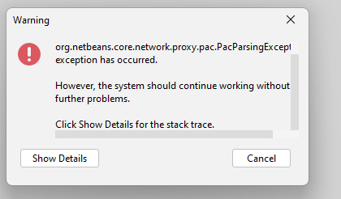

Dateails

org.netbeans.core.network.proxy.pac.PacParsingException: Cannot find secure PAC script engine.
Allowed engines: GraalVM:js,Graal.js,Nashorn
Found engines:
Will not resolve proxy configuration.
Brand ALLOWED_PAC_ENGINES key in org.netbeans.core.network.proxy.pac.impl.Bundle to configure.

at org.netbeans.core.network.proxy.pac.impl.NbPacScriptEvaluator.getScriptEngine(NbPacScriptEvaluator.java:286)
at org.netbeans.core.network.proxy.pac.impl.NbPacScriptEvaluator.<init>(NbPacScriptEvaluator.java:204)
at org.netbeans.core.network.proxy.pac.impl.NbPacScriptEvaluatorFactory.createPacScriptEvaluator(NbPacScriptEvaluatorFactory.java:45)
[catch] at org.netbeans.core.network.proxy.ProxyAutoConfig.initEngine(ProxyAutoConfig.java:114)
at org.netbeans.core.network.proxy.ProxyAutoConfig$1.run(ProxyAutoConfig.java:82)
at org.openide.util.RequestProcessor$Task.run(RequestProcessor.java:1420)
at org.netbeans.modules.openide.util.GlobalLookup.execute(GlobalLookup.java:45)
at org.openide.util.lookup.Lookups.executeWith(Lookups.java:287)
at org.openide.util.RequestProcessor$Processor.run(RequestProcessor.java:2035)

Issue 1 : rename frequency to aggregation frequency

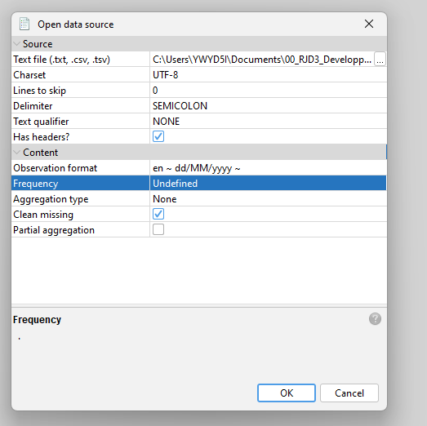

Issue 2 : Incubator M12
No main results display

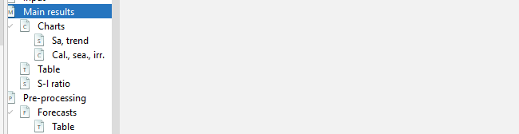

In D final table : dots before column names
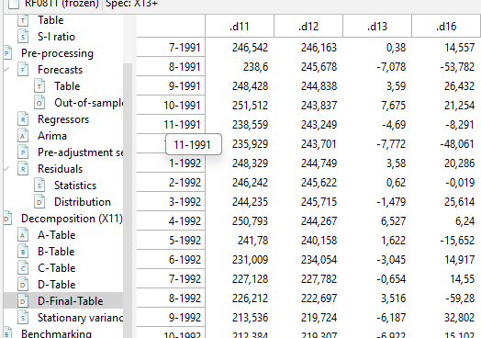

Issue name and label when importing external variables

Issue when saving a WS no mesage when over-wrinting an existing WS

Issue passage en mode multiplicatif

Voir dans Multi P

